

**Database of a vehicle insurance company**

Report

CS310

Database Management Systems

Under the guidance of :-

* Dr. Uma S
* Dr.Pramod Yelmewad
* Ms. Supriya Nadiger

Team members **:-**

* Gitesh Ambre(20bcs009)
* Michael Roy(20bcs010)
* Ashis J Kalathil(20bcs022)
* Chaitanya Giri (20bcs034)
* Dipesh Mishra (20bcs043)
* Harshal Ram Dube(20bcs052)
* Hemang Ranga(20bcs057)
* Prathamesh pai(20bcs103)
* Sunil Patidar(20bcs131)

Objective**:** To gain practical knowledge on the working of a DBMS, to gain practical experience in advanced entity modelling, normalisation & transactional relational database design and being able to apply all these principles in order to make a good DB, that could be used with analytical tools and faster in delivering the right data at the right time for better decision making.

Abstract**:** The Insurance management system organizes and tracks insurance vendors and the policies provided under different coverage. Details of payment, time period, vehicle details, customer personal details, insurance specifications are updated to the database.

There is a need for an automated system, which can efficiently manage the company, records, provides instant access and one that improves productivity. As a result of this automated system, the activities of the company are performed within the stipulated time and the reliable and efficient service is ensured to its users.

The insurance company needs to keep track of details of its target companies, agents, policyholders, their premium payments and the various products that are available with it. Hence it is under tremendous pressure maintaining their day-to-day activities, which is currently being done manually.

Tech stack used**:**

* MySQL Workbench
* GitHub
* Node JS
* React JS
* Express JS
* HTML 5
* CSS 3

Conceptual database model**:**

The conceptual data model is a structured business view of the data required to support business processes, record business events, and track related performance measures. This model focuses on identifying the data used in the business but not its processing flow or physical characteristics. This model’s perspective is independent of any underlying business applications.

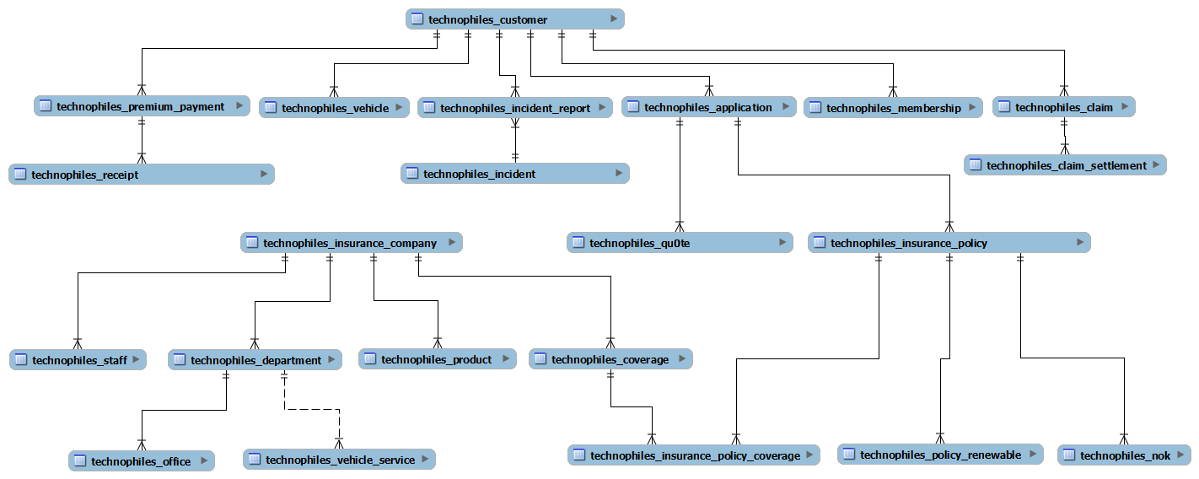

Logical data model**:**

The Logical Data Model is used to define the structure of data elements and to set relationships between them. The logical data model adds further information to the conceptual data model elements. The advantage of using a Logical data model is to provide a foundation to form the base for the Physical model. However, the modelling structure remains generic.

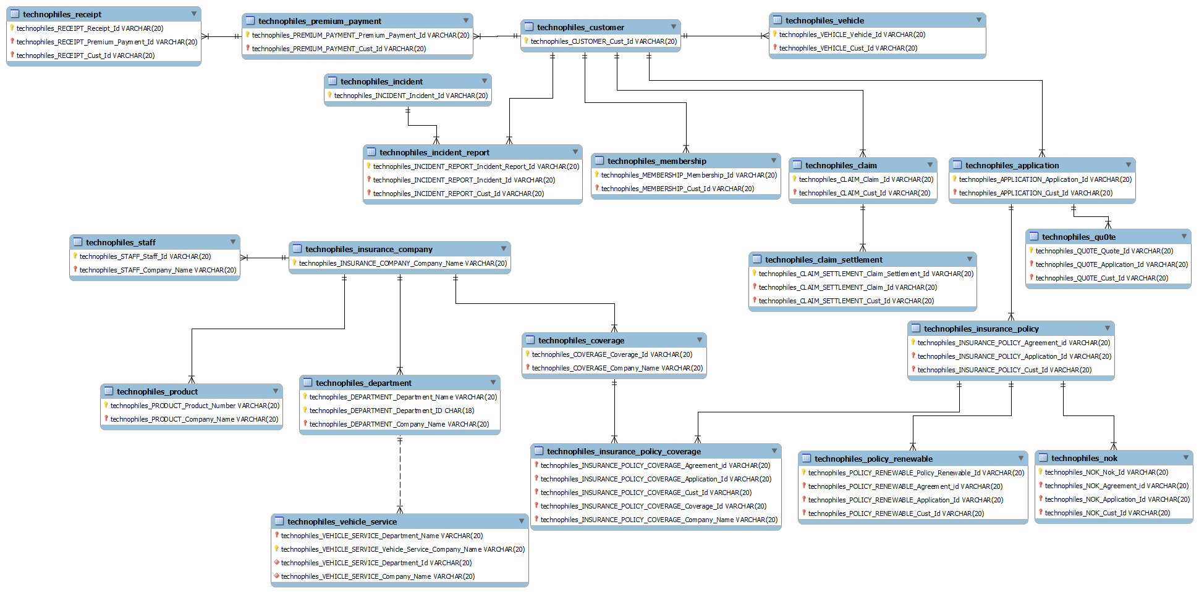

Physical Data Model**:**

A Physical Data Model describes a database-specific implementation of the data model. It offers database abstraction and helps generate the schema. This is because of the richness of meta-data offered by a Physical Data Model. The physical data model also helps in visualizing database structure by replicating database column keys, constraints, indexes, triggers, and other RDBMS features.

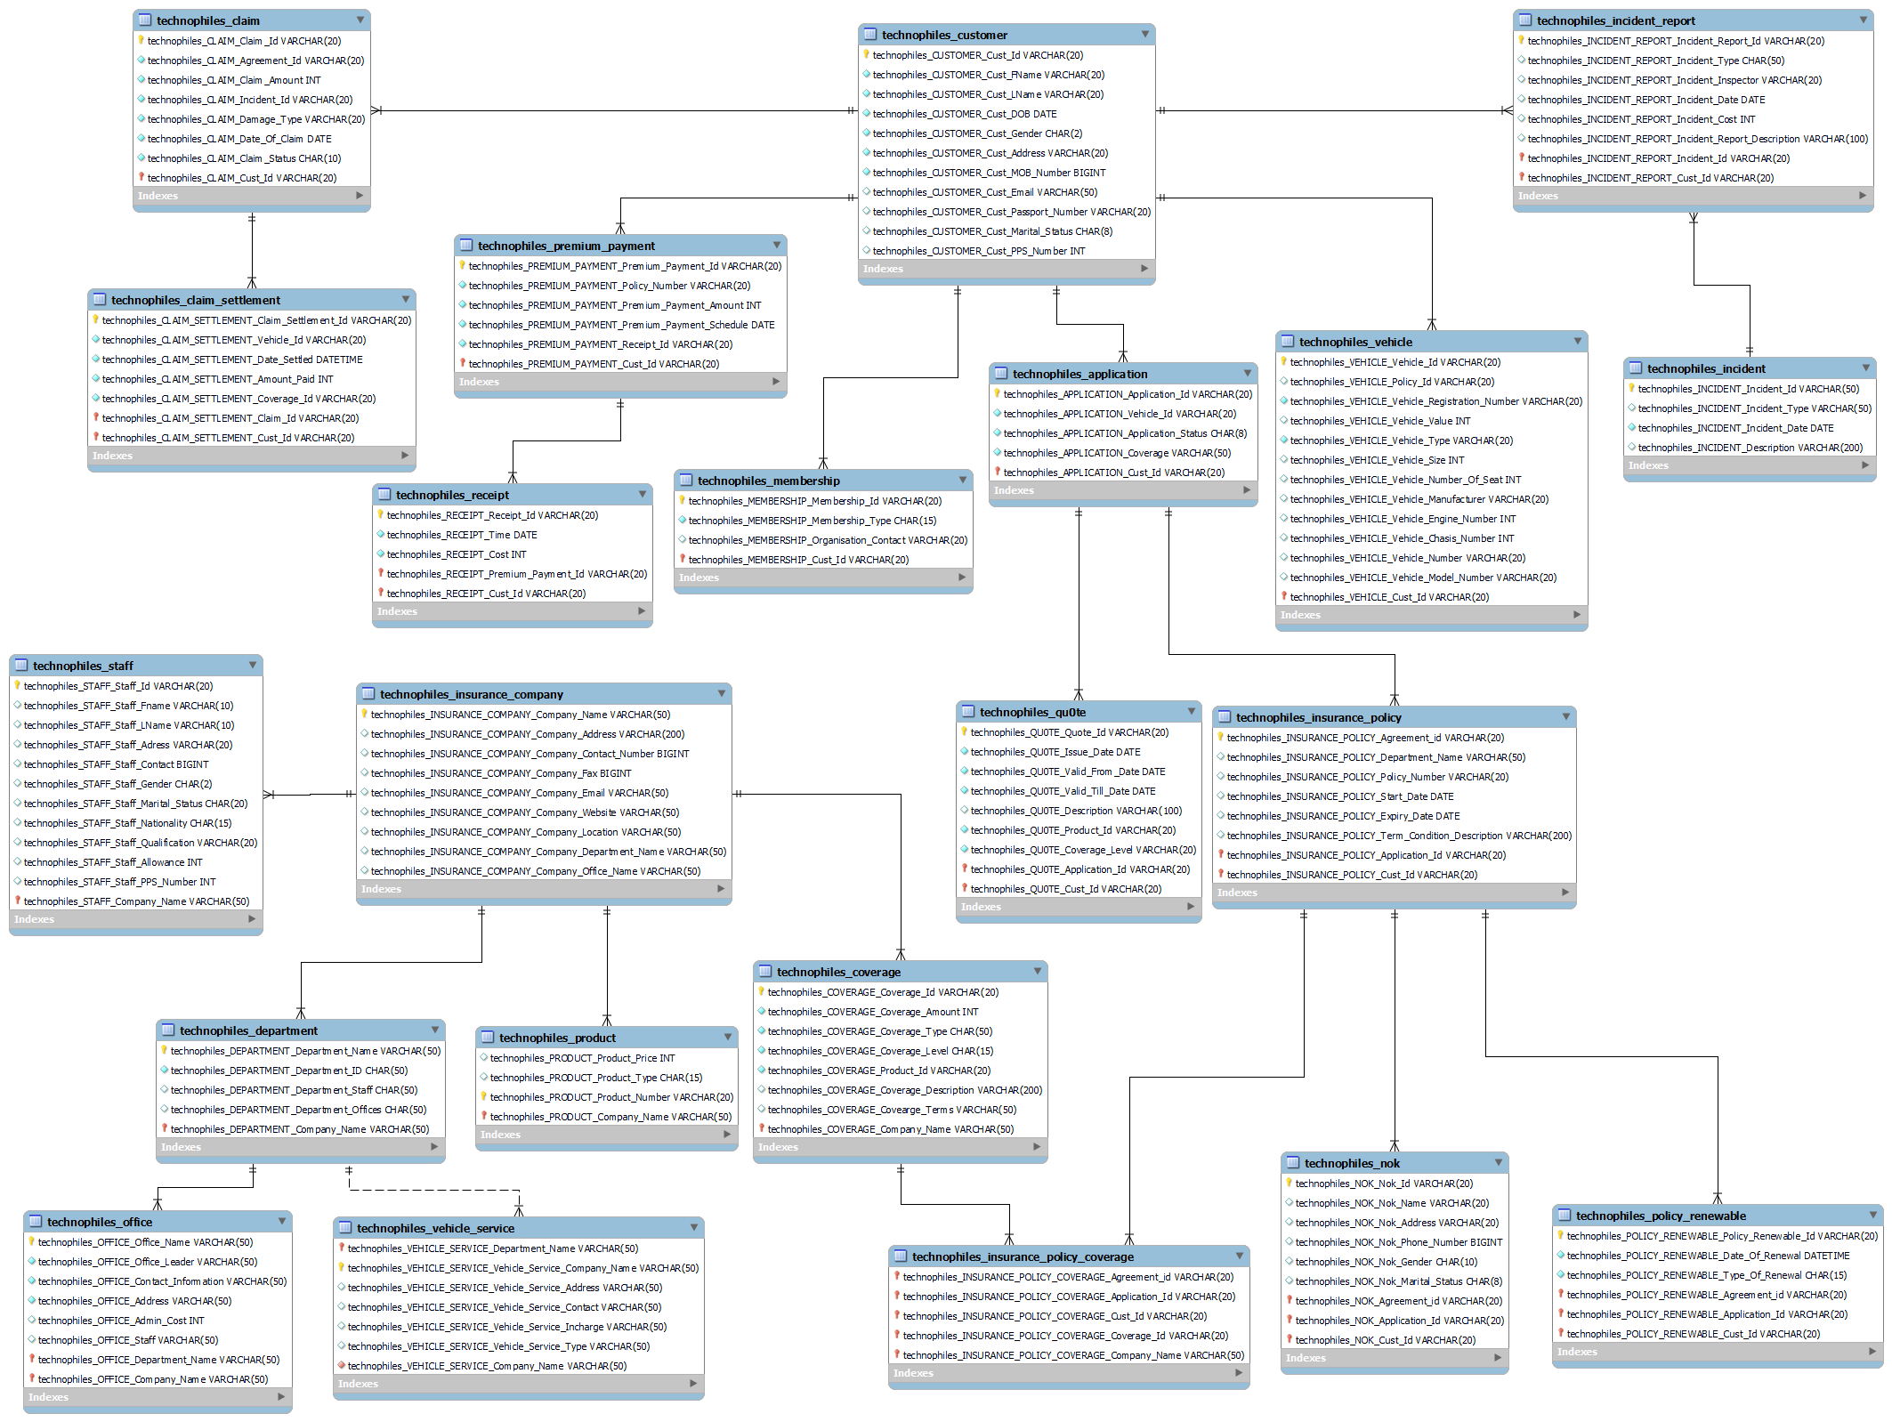

Queries**:**

**-- 1. Retrieve Customer and Vehicle details who has been involved in an incident and claim status is pending – Customer, vehicle, claim status, incident**

select

c.technophiles_CUSTOMER_Cust_Id as cust_id,

concat(

c.technophiles_CUSTOMER_Cust_FName,

" ",

c.technophiles_CUSTOMER_Cust_LName

) as cust_name,

v.technophiles_VEHICLE_Vehicle_Id as vehicle_id,

v.technophiles_VEHICLE_Vehicle_Type as vehicle_type,

v.technophiles_VEHICLE_Vehicle_Value as vehicle_value,

i.technophiles_INCIDENT_REPORT_Incident_Report_Id as incident_report_id,

i.technophiles_INCIDENT_REPORT_Incident_Type as incident_type,

cl.technophiles_CLAIM_Claim_Status as claim_status

from

technophiles_CUSTOMER c

join technophiles_VEHICLE v on c.technophiles_CUSTOMER_Cust_Id = v.technophiles_VEHICLE_Cust_Id

join technophiles_INCIDENT_REPORT i on c.technophiles_CUSTOMER_Cust_Id = i.technophiles_INCIDENT_REPORT_Cust_Id

join (

select

distinct c.technophiles_CLAIM_Cust_Id,

c.technophiles_CLAIM_Claim_Status

from

technophiles_CLAIM c

where

c.technophiles_CLAIM_Claim_Status = "Pending"

) as cl on cl.technophiles_CLAIM_Cust_Id = c.technophiles_CUSTOMER_Cust_Id;

**-- 2. Retrieve customer details who has premium payment amount greater than the sum of all the customerIds in the database – premium payment, customer**

select

c.technophiles_CUSTOMER_Cust_Id as cust_id,

concat(

c.technophiles_CUSTOMER_Cust_FName,

" ",

c.technophiles_CUSTOMER_Cust_LName

) as cust_name,

c.technophiles_CUSTOMER_Cust_Gender as cust_gender,

p.technophiles_PREMIUM_PAYMENT_Premium_Payment_Id as payment_id,

p.technophiles_PREMIUM_PAYMENT_Premium_Payment_Amount as payment_amount,

(select

sum(c.technophiles_CUSTOMER_Cust_Id)

from

technophiles_CUSTOMER c) as sum_of_cust_ids

from

technophiles_CUSTOMER c

join technophiles_PREMIUM_PAYMENT p on p.technophiles_PREMIUM_PAYMENT_Cust_Id = c.technophiles_CUSTOMER_Cust_Id

where

p.technophiles_PREMIUM_PAYMENT_Premium_Payment_Amount > (

select

sum(c.technophiles_CUSTOMER_Cust_Id)

from

technophiles_CUSTOMER c

);

**-- 3. Retrieve Company details whose number of products is greater than departments, where the departments are located in more than one location—company, product, departments, office**

select

c.technophiles_INSURANCE_COMPANY_Company_id as company_id,

c.technophiles_INSURANCE_COMPANY_Company_Name as company_Name,

c.technophiles_INSURANCE_COMPANY_Company_Contact_Number as "contact_no.",

c.technophiles_INSURANCE_COMPANY_Company_Location as company_location,

count(distinct d.technophiles_DEPARTMENT_Department_id) as num_of_departments,

count(p.technophiles_PRODUCT_Product_Number) as num_of_products

from

technophiles_INSURANCE_COMPANY c

join technophiles_PRODUCT p on c.technophiles_INSURANCE_COMPANY_Company_id = p.technophiles_PRODUCT_Company_id

join (

select

d.*

from

technophiles_DEPARTMENT d

join technophiles_OFFICE o on o.technophiles_OFFICE_Department_id = d.technophiles_DEPARTMENT_Department_id

group by

d.technophiles_DEPARTMENT_Department_id

having

count(o.technophiles_OFFICE_Office_Name) > 1

) as d on d.technophiles_DEPARTMENT_Company_id = c.technophiles_INSURANCE_COMPANY_Company_id

group by

c.technophiles_INSURANCE_COMPANY_Company_id

having

count(distinct d.technophiles_DEPARTMENT_Department_id) < count(p.technophiles_PRODUCT_Product_Number);

**-- 4. Select Customers who have more than one Vehicle, where the premium for one of the Vehicles is not paid and it is involved in accident**

select

c.technophiles_CUSTOMER_Cust_Id as cust_id,

concat(c.technophiles_CUSTOMER_Cust_FName, " ", c.technophiles_CUSTOMER_Cust_LName) as cust_name,

c.technophiles_CUSTOMER_Cust_Gender as cust_gender,

count(v.technophiles_VEHICLE_Vehicle_Id) as num_of_vehicles,

r.technophiles_INCIDENT_REPORT_Incident_Report_Id as incident_report_id,

r.technophiles_INCIDENT_REPORT_Incident_Type as incident_type,

Premium_Payment_Amount,

total_paid

from

technophiles_CUSTOMER c

join technophiles_VEHICLE v on c.technophiles_CUSTOMER_Cust_Id = v.technophiles_VEHICLE_Cust_Id

join (

select

technophiles_PREMIUM_PAYMENT_Cust_Id,

technophiles_PREMIUM_PAYMENT_Premium_Payment_Amount,

sum(r.technophiles_RECEIPT_Cost) as total_paid,

technophiles_PREMIUM_PAYMENT_Premium_Payment_Amount as Premium_Payment_Amount

from

technophiles_PREMIUM_PAYMENT p

join technophiles_RECEIPT r on p.technophiles_PREMIUM_PAYMENT_Premium_Payment_Id = r.technophiles_RECEIPT_Premium_Payment_Id

and p.technophiles_PREMIUM_PAYMENT_Cust_Id = r.technophiles_RECEIPT_Cust_Id

group by

p.technophiles_PREMIUM_PAYMENT_Cust_Id,

p.technophiles_PREMIUM_PAYMENT_Premium_Payment_Id

having

sum(r.technophiles_RECEIPT_Cost) < technophiles_PREMIUM_PAYMENT_Premium_Payment_Amount

) as pr on c.technophiles_CUSTOMER_Cust_Id = pr.technophiles_PREMIUM_PAYMENT_Cust_Id

join technophiles_INCIDENT_REPORT r on c.technophiles_CUSTOMER_Cust_Id = r.technophiles_INCIDENT_REPORT_Cust_Id

group by

v.technophiles_VEHICLE_Cust_Id

having

count(v.technophiles_VEHICLE_Vehicle_Id) > 1;

**-- 5. Select all vehicles which have premium more than its vehicle number.**

select

c.technophiles_CUSTOMER_Cust_Id as cust_id,

concat(

c.technophiles_CUSTOMER_Cust_FName,

" ",

c.technophiles_CUSTOMER_Cust_LName

) as cust_name,

-- c.technophiles_CUSTOMER_Cust_Gender as cust_gender,

v.technophiles_VEHICLE_Vehicle_Id as vehicle_id,

-- v.technophiles_VEHICLE_Vehicle_Manufacturer as vehicle_manufacturer,

v.technophiles_VEHICLE_Vehicle_Type as vehicle_type,

v.technophiles_VEHICLE_Vehicle_Number as vehicle_number,

p.technophiles_PREMIUM_PAYMENT_Premium_Payment_Amount as premium_amount

from

technophiles_CUSTOMER c

join technophiles_VEHICLE v on c.technophiles_CUSTOMER_Cust_Id = v.technophiles_VEHICLE_Cust_Id

join technophiles_PREMIUM_PAYMENT p on p.technophiles_PREMIUM_PAYMENT_Cust_Id = c.technophiles_CUSTOMER_Cust_Id

where

v.technophiles_VEHICLE_Vehicle_Number <= p.technophiles_PREMIUM_PAYMENT_Premium_Payment_Amount;

**-- 6. Retrieve Customer details whose Claim Amount is less than Coverage Amount and Claim Amount is greater than Sum of (CLAIM_SETTLEMENT_ID, VEHICLE_ID, CLAIM_ID, CUST_ID)**

select

c.technophiles_CUSTOMER_Cust_Id as cust_id,

concat(c.technophiles_CUSTOMER_Cust_FName, " ", c.technophiles_CUSTOMER_Cust_LName) as cust_name,

c.technophiles_CUSTOMER_Cust_Gender as cust_gender,

cv.technophiles_COVERAGE_Coverage_Amount as coverage_amount,

cl.technophiles_CLAIM_Claim_Amount as claim_amount,

(

cs.technophiles_CLAIM_SETTLEMENT_Claim_Settlement_Id + cs.technophiles_CLAIM_SETTLEMENT_Vehicle_Id + cs.technophiles_CLAIM_SETTLEMENT_Claim_Id + c.technophiles_CUSTOMER_Cust_Id

) as sum_of_ids

from

technophiles_CUSTOMER c

join technophiles_CLAIM cl on c.technophiles_CUSTOMER_Cust_Id = cl.technophiles_CLAIM_Cust_Id

join technophiles_CLAIM_SETTLEMENT cs on cl.technophiles_CLAIM_Claim_Id = cs.technophiles_CLAIM_SETTLEMENT_Claim_Id

join technophiles_COVERAGE cv on cs.technophiles_CLAIM_SETTLEMENT_Coverage_Id = cv.technophiles_COVERAGE_Coverage_Id

where

cl.technophiles_CLAIM_Claim_Amount < cv.technophiles_COVERAGE_Coverage_Amount

and cl.technophiles_CLAIM_Claim_Amount > (

cs.technophiles_CLAIM_SETTLEMENT_Claim_Settlement_Id + cs.technophiles_CLAIM_SETTLEMENT_Vehicle_Id + cs.technophiles_CLAIM_SETTLEMENT_Claim_Id + c.technophiles_CUSTOMER_Cust_Id

);

Conclusion **:-**

**Query 1:-**

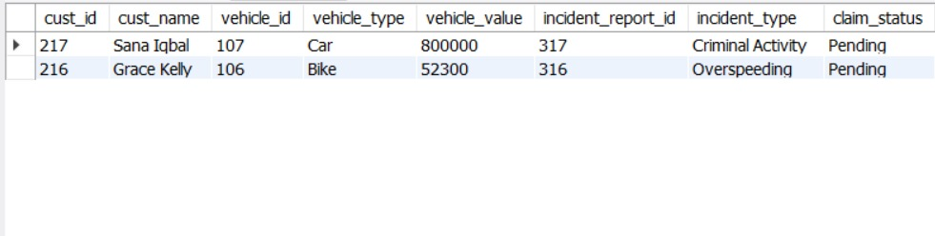

**Query 2:-**

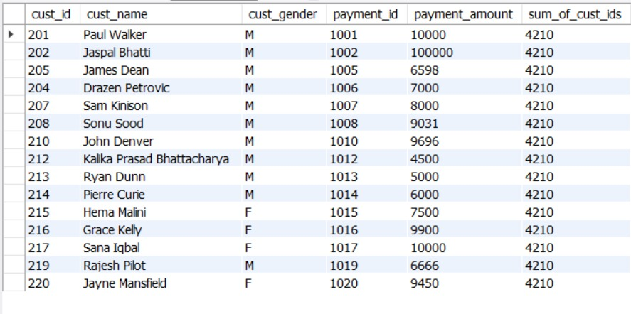

**Query 3:-**

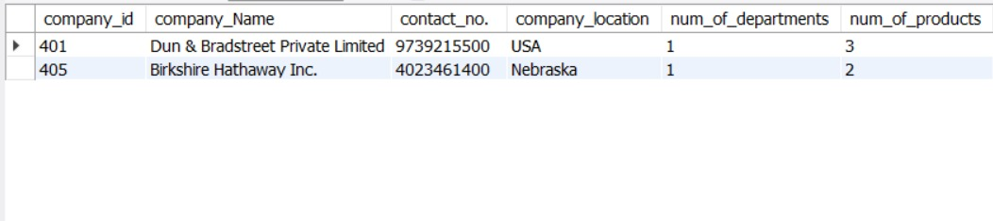

**Query 4:-**

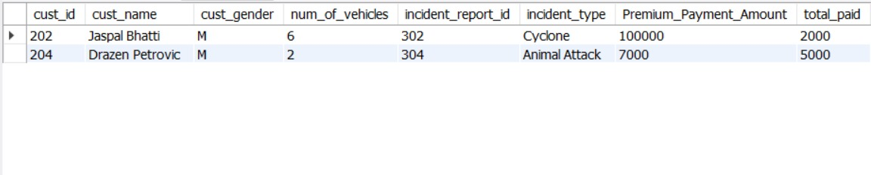

**Query 5:-**

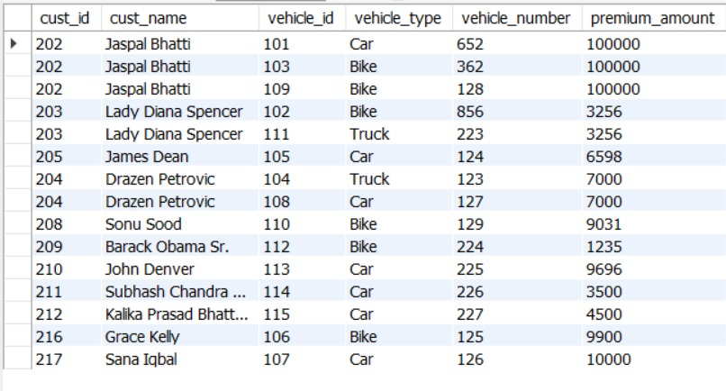

**Query 6:-**

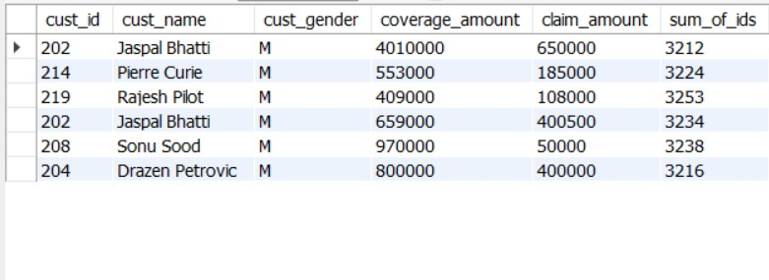

**Website :-**



